**Scott-Knot Test Report**

|  |  |  |
| --- | --- | --- |
| **Algorithm** | **Mean_Square** | **Rank** |
| HMM | 0.4691760 | 1.0 |
| RFC | 0.4991236 | 2.5 |
| NSVM | 0.4991236 | 2.5 |
| MNB | 0.5000000 | 4.5 |
| SVM | 0.5000000 | 4.5 |

The following is a summary of how well certain algorithms performed based on their mean square values and ranks:

**HMM (Hidden Markov Model):** This algorithm performed better than the others, achieving a highest rank of 1.0 with a mean square value of roughly 0.4692.

**Random Forest Classifier (RFC) and Nonlinear Support Vector Machine (NSVM):** Both methods achieved mean square values that were roughly 0.4991 and had a rank of 2.5, which was shared by both.

**MNB (Multinomial Naive Bayes) and SVM (Support Vector Machine):** Among the algorithms under analysis, these algorithms have the lowest prediction accuracy, as indicated by their greatest mean square values of 0.5. 4.5 was their combined rank, which put them in fourth place.

To summarize, the Hidden Markov Model (HMM) demonstrated the lowest mean square value and obtained the highest rank, outperforming the other algorithms. On the other hand, lower ranks and greater mean square values were displayed by Support Vector Machine (SVM) and Multinomial Naive Bayes (MNB), suggesting that their predicted accuracy was significantly worse.

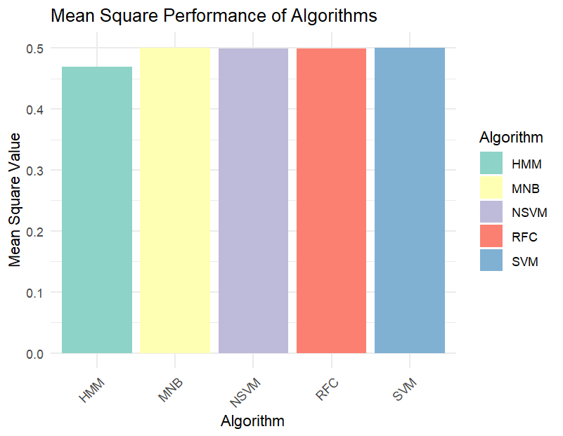

Fig: Bar Graph for Mean Square Value in Scott-Knot test

|  |  |
| --- | --- |
| **Measure** | **Value** |
| Minimum | 0.4692 |
| 1st Quartile | 0.4991 |
| Median | 0.4991 |
| Mean | 0.4935 |
| 3rd Quartile | 0.5000 |
| Maximum | 0.50000000 |

Here is a summarized report with all techniques included, based on the mean square values of five different methods' reported summary data.

The summary statistics for the mean square values of the algorithms are as follows:

**Minimum:** The lowest mean square value observed is 0.4692.

**1st Quartile:** 25% of the mean square values fall below 0.4991.

**Median:** The median mean square value is 0.4991, representing the middle value when all mean square values are sorted in ascending order.

**Mean:** The average mean square value across all algorithms is approximately 0.4935.

**3rd Quartile:** 75% of the mean square values fall below 0.5000.

**Maximum:** The highest mean square value observed is 0.5000.

The distribution and central tendency of the mean square values are revealed by these summary statistics. Considering how near the mean and median are to one another, the distribution is essentially symmetric. The difference between the first and third quartiles, or the interquartile range, or IQR, ranges from 0.4991 to 0.5000, indicating comparatively little fluctuation in the middle 50% of the data.

With a mean square value of 0.4692, the Hidden Markov Model (HMM) algorithm stands out among the others under analysis, suggesting better prediction accuracy than the others.